

**WQD7012 APPLIED MACHINE LEARNING**

**OCCURRENCE 3**

**SEMESTER 2 SESSION 2024/2025**

***TUTORIAL 5***

**NAME:**

BARKAVI A/P P CHEVEN (23093149)

**LECTURER’S NAME:**

DR RIYAZ AHAMED ARIYALURAN HABEEB MOHAMED

**PRACTICAL – REGRESSION METHODS**

**INSTRUCTIONS: PRACTICAL-REGRESSION METHODS ON CARS DATASET**

Please provide evidence in the form of screenshots or code snippets demonstrating the implementation of three different regression techniques. These should reflect your understanding of regression concepts, including simple linear regression, multiple linear regression, and polynomial regression, using the car dataset for analysis. Make sure to attach the Google Colab link in the submission file as well

**PROOF OF IMPLEMENTATION OF ALL REGRESSION TECHNIQUES**

1. Simple Linear Regression (predicts CO2 emissions based solely on engine volume : )

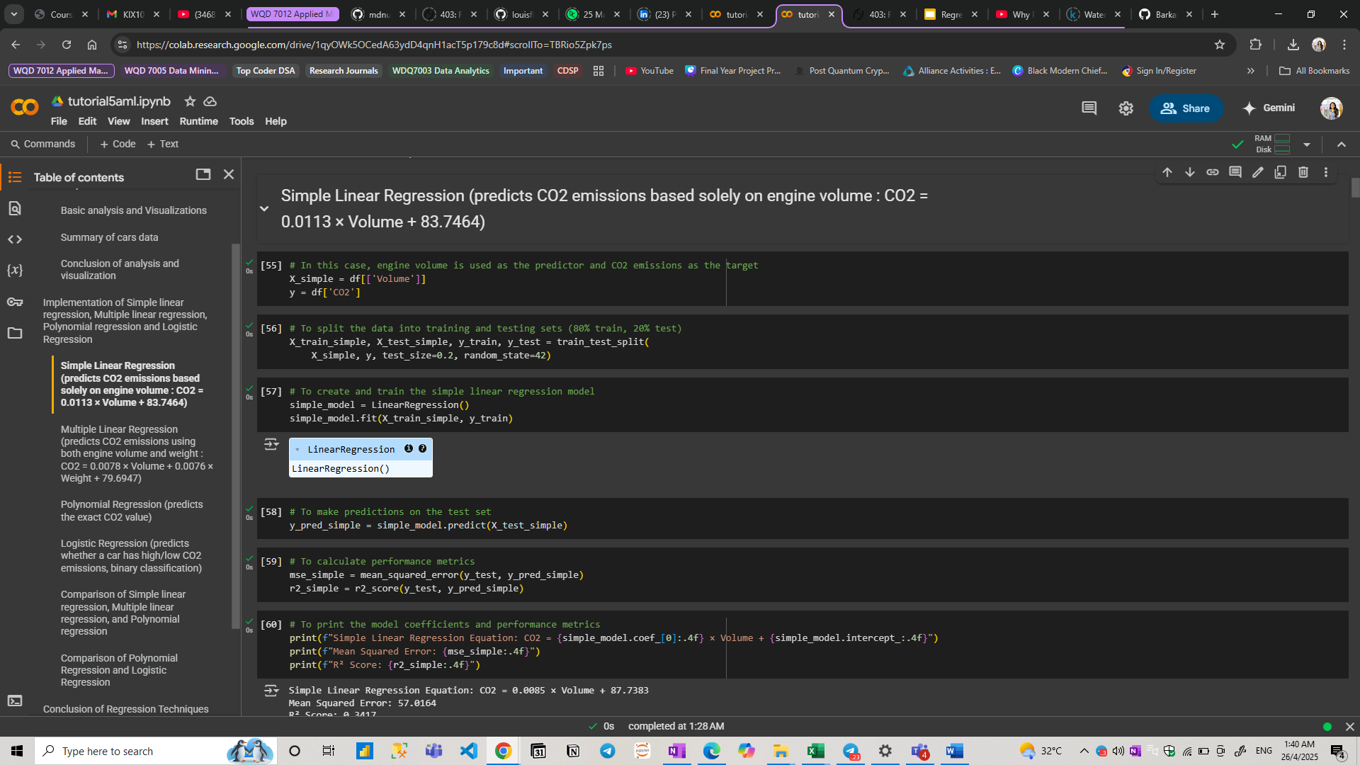

1. Multiple Linear Regression (predicts CO2 emissions using both engine volume and weight : )

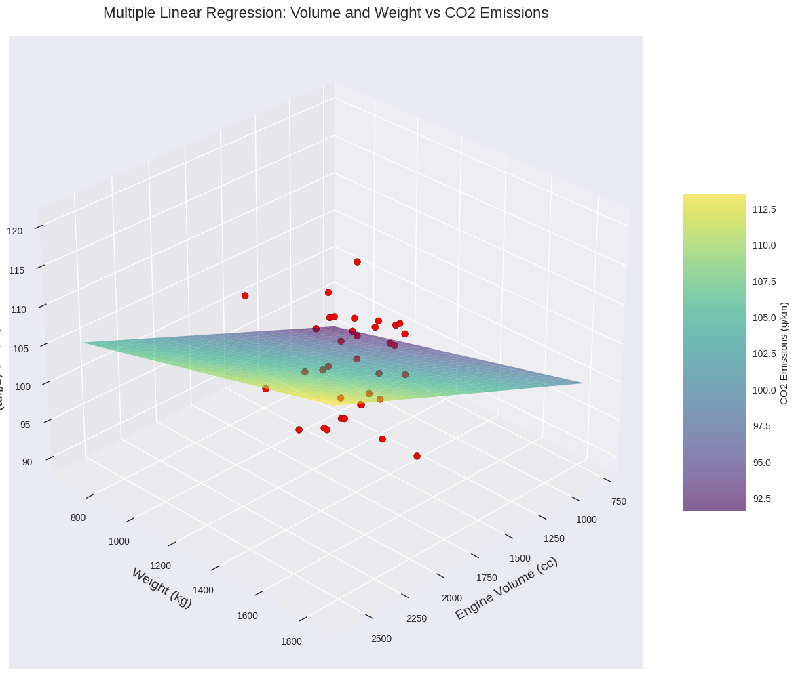

1. Polynomial Regression (predicts the exact CO2 value)

1. Logistic Regression (predicts whether a car has high/low CO2 emissions, binary classification)

